Implementing loss models based on splicing
PAUL KAMAU November 06, 2025

Contents
- Introduction 2
- Severity modeling - Unique data generating process 2
  - Data - Secura Re 2
  - Unique data generating process approach 3
    - Exponential distribution 3
    - Lognormal distribution 4
- Severity modeling - Splicing 5
  - Splicing - The theory 6
  - Body-Tail approach 6
    - Tail modeling - The generalized pareto distribution 6
    - Exponential body, GPD tail 7
    - Lognormal body, GPD tail 9
Appendices 10
A Code fractions 10
  - Secura Re - Exponential model fit 10
  - Secura Re - Lognormal model fit 12
  - Splicing - Exponential body, GPD tail 13
  - Splicing - lognormal body, GPD tail 15

Introduction
In an insurance and financial context it is important to have a clear view on both the risk and return aspects of contingent claims. From a risk management point of view, an insurer must take worst case scenarios into account and anticipate their potential future realizations. As such, extreme historical events can not be discarded during the modelling process and they must be handled appropriately. In this paper we review a body and tail splicing approach for modeling extreme events. The goal of this approach is to take tail events into account explicitly by combining separate data generating processes for both the body and the tail of the distribution. As a practical consideration, the resulting model can assist an insurance company in the pricing of an unlimited excess-loss layer
above an operational priority R.

Severity modeling - Unique data generating process
In this chapter we investigate the properties of a loss distribution and attempt to model the corresponding data sample by using a single data generating process. We start with an overview on the data characteristics and then proceed by fitting an exponential and a lognormal model to the sample. We conclude with an analysis regarding the goodness of fit of the respective models.

Data - Secura Re
In this paper we investigate the properties of the famous ’Secura Re’ data set. The data contains realizations of losses that lie in the excess-loss layer above above an operational priority R = 1200000. The top two plots in figure 1. below show the empirical distribution function and the histogram of the data. The bottom left graph illustrates the severity of the losses per year while the bottom right graph shows a boxplot for the complete data set. The latter two plots illustrate that the data distribution is skewed to the right, and that an appropriate model should be selected to accommodate for potential future occurances of these extreme loss events.

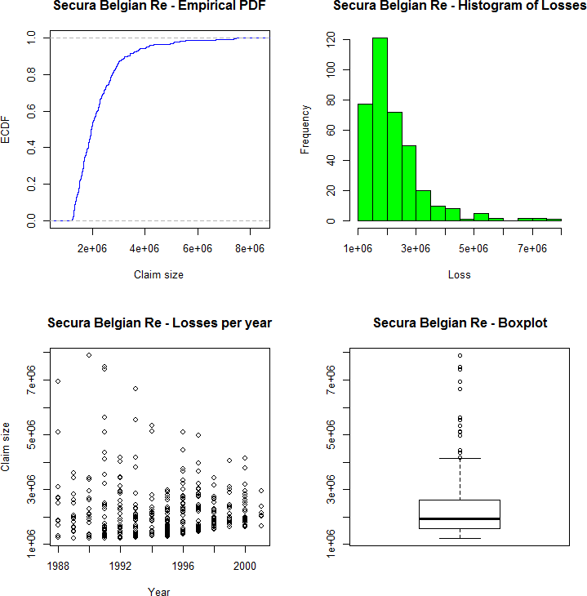

Figure 1: Secura Re - Empirical data

Unique data generating process approach

Exponential distribution
At first glance, the top two plots in figure 1. imply that an exponential distri- bution could potentially be a good fit for the data generating process of claim severity’s that are greater than R. Hence, in this subsection we make the fol- lowing assumption while modelling the data: (X − R) ∼ Exp(λ).
Appendix A.1 illustrates the calibration of the data to this exponential model. Here, we choose to calibrate the model via a maximum likelihood ap- proach, for comparison reasons later on. Alternatively, the rate parameter λ of the exponential distribution can also be obtained via the method of moments. Figure 2. shows the results of the calibration process. The top two graphs

suggest that the model density and CDF are a relatively good fit for the em- pirical data. The bottom plot shows the QQ plot of the model quantiles versus the empirical quantiles. The plot implies that the model captures the loss data sufficiently well at the lower severity spectrum while data at the right tail is not adequately captured. We notice that most occurrences in the outer tail are slightly underestimated while the most severe occurences are understimated by the model. The AIC criterion for this model is 11017.52.
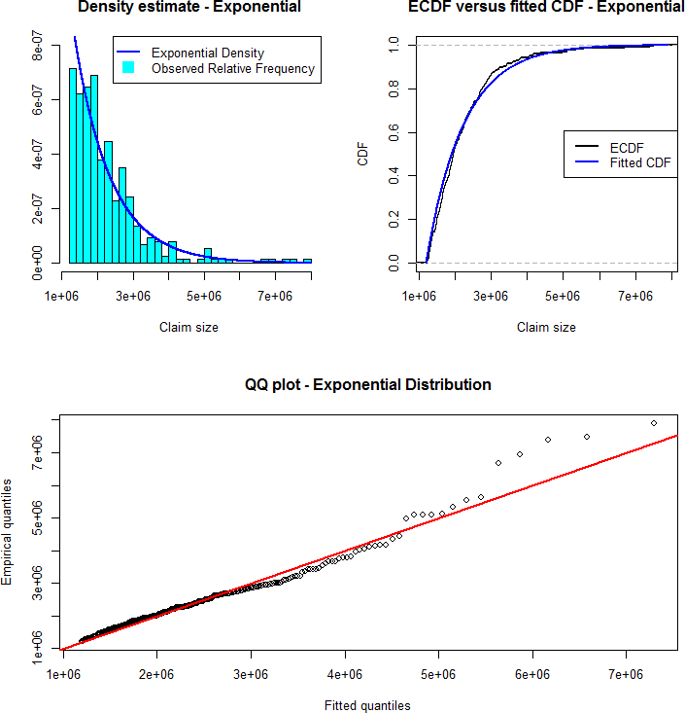

Figure 2: Secura Re - Exponential model fit

Lognormal distribution
In this subsection we repeat the fitting process for a lognormal distribution. Appendix A.2 illustrates the calibration of the data to the lognormal model;

Results are illustrated in figure 3. below. In comparison to the previous expo- nential model, we now again notice that the model fits the losses in the lower end of the severity spectrum adequately well. However, severity’s of extreme losses are now strongly overestimated by the long right tail of the lognormal distribution. The AIC for this model is 11047.23.
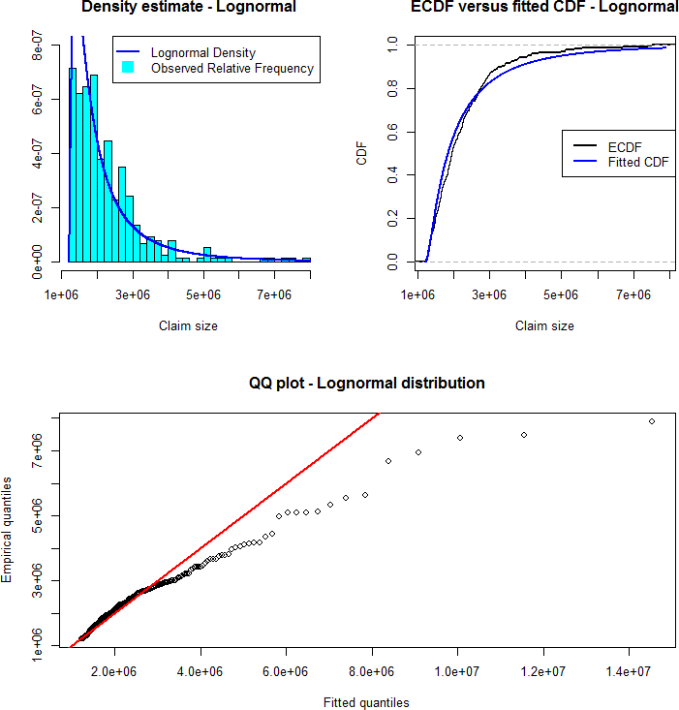

Figure 3: Secura Re - Lognormal model fit

Severity modeling - Splicing
In the previous chapter we illustrated that a single data generating process insufficiently captures the complete loss distribution spectrum. More precisely, the extreme losses in the tails are not captured adequately by these simple models. In this chapter we give a theoretical overview on splicing, which allows

us to overcome the latter problem. We then illustrate the concepts by calibrating two spliced distribution models to the loss data of the previous chapter.

Splicing - The theory
Splicing allows us to model a data set or data generating process by using multi- ple processes that are each responsible for generating data in distinct intervals. More concretely, a k-component spliced distribution has a density function that can be expressed as follows:

a₁ · f₁(x), c₀ ≤ x < c₁


f_{X} (x) =
a₂ · f₂(x), c₁ ≤ x < c₂
... ...

a_{k} · f_{k}(x), c_{k−1} ≤ x < c_{k}

For j = 1, ..., k, each a_{j} > 0 and each f_{j}(x) is a legitimate pdf with all prob- ability on the interval [c_{j−1}, c_{j}), and j a_{j} = 1. As an example, suppose that there are k pdfs, denoted by g₁(x), ..., g_{k}(x) defined on the support Ω_{x} = [0, inf). If we want f_{j}(x) to be a legitimate pdf based on g_{j}(x) restricted on the interval
Σ
[c_{j−1}, c_{j}) for i = 1, ..., k, then we can use f_{j}(x) = ^{g}j (x) . For the a_{j} we can use the empirical probabilities that x lies in the interval [c_{j−1}, c_{j}).
Gj (c)−Gi(cj−1)
In the context of this paper, splicing means that the density function of the losses can be modeled by using multiple data generating processes which correspond to different loss severity intervals.

Body-Tail approach
We investigate a body and tail splicing approach where a distribution for the body of the data is combined with a separate distribution for the tail. We start with a small overview on the generalized pareto distribution (GPD) because we will use this family of distributions to model the data in the tail. We then proceed with the calibration process and analyze the results in comparison to the single distribution approach.

Tail modeling - The generalized pareto distribution
The generalized pareto distribution is often used to model the tails of other distributions and is specified by 3 parameters: location µ, scale σ, and shape ε. The pdf of the distribution can be written as follows:

f (x) = 1 (1 + ε(x−µ) )(− 1 −1)

ε,µ,σ σ σ ε
and corresponding CDF:

(1 − (1 + ^{ε(x−µ)} ) −1 , for ε /= 0
ε

Fε,µ,σ (x) =
σ
1 − exp(− ^{x−µ} ), for ε = 0
σ

In this paper we use a GPD with µ = 0 to model the losses above a certain threshold x_{b} = 2580026. The value of x_{b} was obtained via extreme value theory and its calculation falls outside the scope of this paper. When evaluating the data set we notice that the amount of losses greater than x_{b} corresponds to about p_{gpd} = 25.6%

Exponential body, GPD tail
In this section we use the exponential distribution to model the body and the GPD distribution to model the tail of the loss distribution. Given our previous definitions of splicing and when taking the operational priority R into account, we arrive at the following model for the data generating process:

f (x) =
G(x_{b})−G(R)
p2 · h(x) , x ≥ xb
1−H(x )
(p1 · g(x) , x < xb
b

Where p₁ = 1−p_{gdp} and p₂ = p_{gdp}. Here, g(.) and G(.) represent the density and cdf of the exponential distribution while h(.) and H(.) represent the density and cdf of the GPD distribution. This specification is equivalent to the model below, which we calibrate as illustrated in appendix A.3:
(p1 · g(x−R) , x < xb
f (x) =
G(x_{b})
p₂ · h(x − x_{b}), x ≥ x_{b}

Figure 4. below illustrates the calibration results. In comparison to the single data generating processes we notice that the bulk of the data in the tail is now captured adequately well by the mixed distribution. Indeed, the AIC for the model is 11009.68, which is lower than the corresponding values of the previous models.

- Exponential and GPD.png
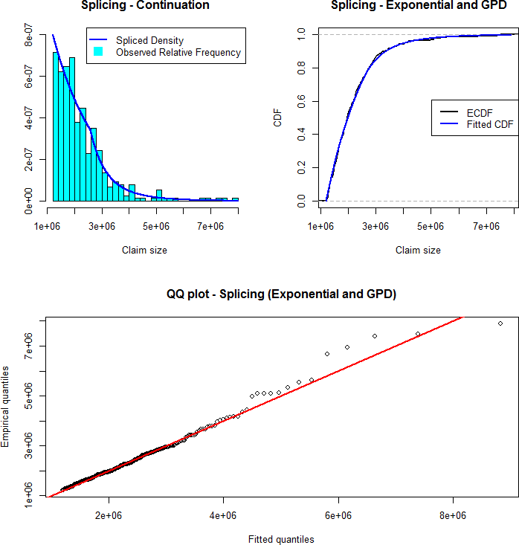

Figure 4: Splicing - Exponential body, GPD tail
Note that we also force p₁ · ^{g(x}b−R) = p₂ ·h(0) during the calibration process.
G(x −R)
b
This implies that σ = ^{p}2 · ^{G(x}b−R) and avoids discontinuity around x_{b}. The top
p₁ g(x_{b}−R)
plot in Figure 5. below illustrates what happens to the density fit when the
continuity condition is not enforced: A discontinuity is clearly visible around the separation point of the two data generating processes, around x = x_{b}.

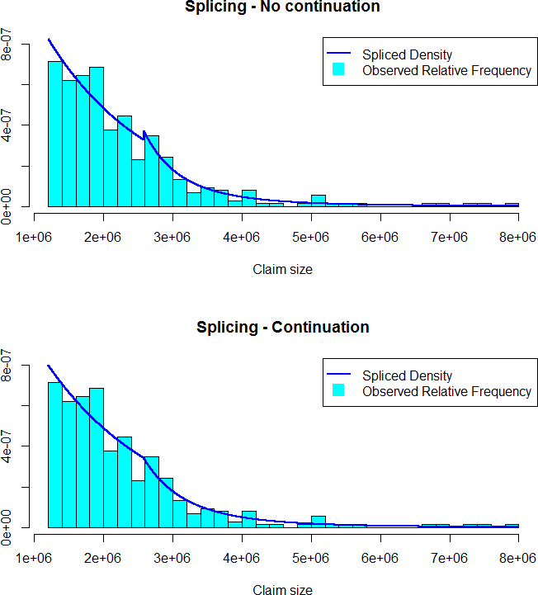

Figure 5: Splicing - Density continuation

Lognormal body, GPD tail
In this subsection we repeat the spliced body and tail calibration process but we now use a lognormal data generating process for the body. Results are illustrated in Figure 6. below. We notice that the results do not differ much from the previous spliced model. The lognormal distribution provides a good fit for the body of the distribution while the extreme outliers are again fitted by the GPD. The AIC for the model is 11008.3, which implies that it is the best out of the 4 models under consideration in this paper.

- Lognormal.png
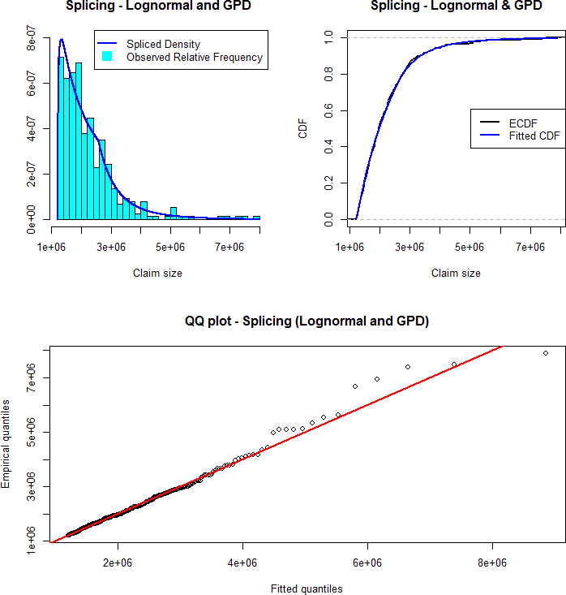

Figure 6: Splicing - Lognormal body, GPD tail

Appendices

Code fractions

Secura Re - Exponential model fit
# 1 . Exponential l i k e l i h o o d
Exp . l i k <− function ( data , p)
{

Exp . lambda <− exp ( p [ 1 ] )
Exp . Lik <− dexp ( data , ra te=Exp . lambda , log=TRUE)
return(−sum( Exp . Lik ))
}
f i t . nlm <− nlm( Exp . l ik , p = c ( log ( 1 /mean( Loss−trunclower ) ) ) ,
data=Loss−trunclower , print . l e v e l =2) Exp . lambda <− exp ( f i t . nlm$ e s t imate [ 1 ] )
layout ( matrix ( c ( 1 , 3 , 2 , 3 ) , nrow=2 , ncol =2))
t r u e h i s t ( Loss , nbins = 40 , ylim = c ( 0 , 8 e −07) , xlab=” Claim s i z e ” , main = ” Density e s t imate −Exponential ” )
curve ( dexp ( x−trunclower , ra te=Exp . lambda ) ,
from = trunclower , to = 8 e +06 , n = 10000 ,
add = TRUE, col = ” blue ” , lwd = 2 )
legend ( ’ to p r ig h t ’ , legend = c ( ” Exponential Density ” ,
” Observed Re la t ive Frequency” ) , col = c ( ” blue ” , ” cyan” ) , pch=c (NA, 1 5 ) , pt . cex=2 , l t y = c ( 1 , NA) , lwd = c ( 2 , NA))
plot ( e cdf ( Loss ) , do . points = FALSE, xlab = ’ Claim s i z e ’ , ylab = ’CDF’ , main = ’ECDF ve rs us f i t t e d CDF−Exponential ’ ,
xlim = c ( trunclower , max( Loss ) ) , lwd = 2 )
curve (( x >= trunclower ) ∗ pexp ( x−trunclower , ra te=Exp . lambda ) , n = 1000 , col = ” blue ” , lwd = 2 , add = TRUE)
legend ( ’ r i g h t ’ , c ( ’ECDF’ , ’ Fitte d CDF’ ) , col = c ( 1 , 4 ) , lwd = 2 )

qExp <− function ( pinput , data ){
# s o l v e F X( x ) = p numerically by minimizing (F X( x ) − p)ˆ2
o b j e c t i v e <− function ( xi ){ x <− exp ( xi )
F X=0
i f ( x >= 0 )
F X <− pexp ( x , ra te=Exp . lambda )
return (( F X−p input ) ˆ2 )
}
optim ( par = log ( qexp ( pinput , 1/mean( data ) ) ) , o b je c t ive , method = ”L−BFGS−B” ) $par
}
n <− length ( Loss )
p <− 1 : n/ ( n+1)
q <− exp ( sapply ( p , qExp , data=Loss−trunclower ) )+ trunclower
q <− qexp ( p , ra te=Exp . lambda)+trunclower
plot ( q , sort ( Loss ) ,
xlab = ” Fitte d q u a n t i l e s ” , ylab = ” Empirical q u a n t i l e s ” , pch=1 ,

main = ”QQ p lo t −Exponential Dis t r ib u t i o n ” )
abline ( a = 0 , b = 1 , lwd = 2 , col = ” red ” )
AIC .EXP <− (+2)∗ f i t . nlm$minimum + 2∗length ( f i t . nlm$ e s t imate ) AIC .EXP

Secura Re - Lognormal model fit
#2 . lognormal l i k e l i h o o d
LN. l i k <− function ( data , p)
{
LN. mu <− p [ 1 ]
LN. sigma <− exp ( p [ 2 ] )
LN. Lik <− dlnorm ( data , meanlog=LN. mu, s dlo g=LN. sigma , log=TRUE)
# LN. Lik <− −lo g ( data ) − l o g (LN. sigma ) −
# 0 . 5 ∗ l o g (2 ∗ p i ) −0.5∗ ( l o g ( data)−LN.mu)ˆ2 /LN. sigmaˆ2
return(−sum(LN. Lik ))
}
f i t . nlm <− nlm(LN. l ik , p = c (mean( log ( Loss−trunclower ) ) ,
log ( sd ( log ( Loss−trunclower ) ) ) ) , data=Loss−trunclower ,
print . l e v e l =2)
LN. mu <− f i t . nlm$ e s t imate [ 1 ]
LN. sigma <− exp ( f i t . nlm$ e s t imate [ 2 ] )
t r u e h i s t ( Loss , nbins = 40 , ylim = c ( 0 , 8 e −07) , main = ” Density e s t imate −Lognormal” ,
xlab = ” Claim s i z e ” )
curve ( dlnorm ( x−trunclower , meanlog=LN. mu, s dlo g=LN. sigma ) , main = ” Density e s t imate −Lognormal” ,
from = trunclower , to = 8 e +06 , n = 10000 ,
add = TRUE, col = ” blue ” , lwd = 2 )
legend ( ’ to p r ig h t ’ , legend = c ( ” Lognormal Density ” ,
” Observed Re la t ive Frequency” ) , col = c ( ” blue ” , ” cyan” ) , pch=c (NA, 1 5 ) , pt . cex=2 , l t y = c ( 1 , NA) , lwd = c ( 2 , NA))
plot ( e cdf ( Loss ) , do . points = FALSE, xlab = ’ Claim s i z e ’ , ylab = ’CDF’ , main = ”ECDF ve rs us f i t t e d CDF−Lognormal” ,
xlim = c ( trunclower , max( Loss ) ) , lwd = 2 )
curve (( x >= trunclower ) ∗ plnorm ( x−trunclower , meanlog=LN. mu, s dlo g=LN. sigma ) , n = 1000 , col = ” blue ” , lwd = 2 , add = TRUE)
legend ( ’ r i g h t ’ , c ( ’ECDF’ , ’ Fitte d CDF’ ) , col = c ( 1 , 4 ) , lwd = 2 ) qLN1 <− function ( pinput , data ){

# s o l v e F X( x ) = p numerically by minimizing (F X( x ) − p)ˆ2
o b j e c t i v e <− function ( xi ){ x <− exp ( xi )
F X=0
i f ( x >= 0 )
F X <− plnorm ( x , meanlog=LN. mu, s dlo g=LN. sigma )
return (( F X−p input ) ˆ2 )
}
optim ( par = log ( qlnorm ( pinput , mean( log ( data ) ) , sd ( log ( data ) ) ) ) ,
o b je c t ive , method = ”L−BFGS−B” ) $par
}
n <− length ( Loss )
p <− 1 : n/ ( n+1)
q <− exp ( sapply ( p , qLN1 , data=Loss−trunclower )) + trunclower
q <− qlnorm ( p , meanlog=LN. mu, s dlo g=LN. sigma)+trunclower
plot ( q , sort ( Loss ) , main = ”QQ p lo t −Lognormal d i s t r i b u t i o n ” ,
xlab = ” Fitte d q u a n t i l e s ” , ylab = ” Empirical q u a n t i l e s ” , pch=1)
abline ( a = 0 , b = 1 , lwd = 2 , col = ” red ” )

AIC . LN <− (+2)∗ f i t . nlm$minimum + 2∗length ( f i t . nlm$ e s t imate ) AIC . LN

Splicing - Exponential body, GPD tail
# t h re sh o l d s p e c i f i e d using EVT t echnique
th re s h o ld = 2580026
# determine s p l i c i n g weights ( using b e r n o u i l l i MLE)
n = length ( Loss )
k = length ( Loss [ Loss > th re s h o ld ] )
# body component
pn <− ( n−k) /n
# t a i l component
k/n
# 3 . Body−Tail : Exponential + GPD
EXPGDP. l i k = function ( p){ EXP. lambda <− exp ( p [ 1 ] )
GDP. shape <− p [ 2 ]
# GDP. sigma <− exp ( p [ 3 ] )

GDP. sigma <− (1−pn ) ∗pexp ( threshold −trunclower , ra te=EXP. lambda ) / ( pn∗dexp ( threshold −trunclower , ra te=EXP. lambda ))

seq Threshold <− which ( Loss <= th re s h o ld ) gt Threshold <− which ( Loss > th re s h o ld )
L1 <− pn ∗ dexp ( Loss [ seq Threshold ]−trunclower ,
ra te=EXP. lambda ) /
pexp ( threshold −trunclower , ra te=EXP. lambda )
L2 <− (1−pn ) ∗ ( 1 /GDP. sigma ) ∗( 1 + (GDP. shape∗
( Loss [ gt Threshold ]− th re s h o ld )) /
GDP. sigma)ˆ(−1−1/GDP. shape )
# Log Likelihood
log L <− sum( c ( log ( c ( L1 , L2 ) ) ) )
return(−log L )
}
# f i t . nlm <− nlm(EXPGDP. l i k , p = c ( l og (1 /mean( Loss−trunclower )) ,
# 1/ 4 , l o g ( 748329 )) , p r int . l e v e l =2)
f i t . nlm <− nlm(EXPGDP. l ik , p = c ( log ( 1 /mean( Loss−trunclower ) ) ,
1/ 4 ) , print . l e v e l =2) Exp . lambda = exp ( f i t . nlm$ e s t imate [ 1 ] )
GDP. shape <− f i t . nlm$ e s t imate [ 2 ]
# GDP. sigma <− exp ( f i t . nlm$ estimate [ 3 ] )

GDP. sigma <− (1−pn ) ∗pexp ( threshold −trunclower , ra te=Exp . lambda ) / ( pn∗dexp ( threshold −trunclower , ra te=Exp . lambda ))
layout ( matrix ( c ( 1 , 3 , 2 , 3 ) , nrow=2 , ncol =2))
t r u e h i s t ( Loss , nbins = 40 , ylim = c ( 0 , 8 e −07) ,
xlab=” Claim s i z e ” , main=” S p l i c i n g −Continuation ” )
curve ( I ( x <= th re s h o ld ) ∗ pn ∗ dexp ( x−trunclower , ra te=Exp . lambda ) / pexp ( threshold −trunclower , ra te=Exp . lambda ) +
(1− I ( x <= th re s h o ld )) ∗ (1−pn ) ∗ ( 1 /GDP. sigma ) ∗
( 1 + (GDP. shape∗( x−th re s h o ld )) /GDP. sigma)ˆ(−1−1/GDP. shape ) , from = trunclower , to = 8 e +06 , n = 10000 ,
add = TRUE, col = ” blue ” , lwd = 2 )
legend ( ’ to p r ig h t ’ , legend = c ( ” Sp l i c e d Density ” ,
” Observed Re la t ive Frequency” ) ,
col = c ( ” blue ” , ” cyan” ) , pch=c (NA, 1 5 ) , pt . cex=2 ,
l t y = c ( 1 , NA) , lwd = c ( 2 , NA))
plot ( e cdf ( Loss ) , do . points = FALSE,
xlab = ’ Claim s i z e ’ , ylab = ’CDF’ ,
main = ’ S p l i c i n g −Exponential and GPD ’ ,
xlim = c ( trunclower , max( Loss ) ) , lwd = 2 )
# Fitt e d CDF
curve (( x >= trunclower ) ∗ (( x <= th re s h o ld ) ∗ pn ∗

pexp ( x−trunclower , ra te=Exp . lambda ) / pexp ( threshold −trunclower , ra te=Exp . lambda ) +
( x > th re s h o ld ) ∗( pn + (1−pn ) ∗(1−(1+ GDP. shape ∗
( x−th re s h o ld ) /GDP. sigma )ˆ( −1/GDP. shape ) ) ) ) ,
n = 1000 , col = ” blue ” , lwd = 2 , add = TRUE)
legend ( ’ r i g h t ’ , c ( ’ECDF’ , ’ Fitte d CDF’ ) , col = c ( 1 , 4 ) , lwd = 2 )
## QQ p l o t
# t h i s f untion t akes a p ro b a b l i t y p as argument
# and returns the q u a n t i l e x f or which F X( x ) = p
q s p l i c i n g <− function ( p){
# s o l v e F X( x ) = p numerically by minimizing (F X( x ) − p)ˆ2
o b j e c t i v e <− function ( xi ){ x <− exp ( xi )
F X=500
i f ( x >= trunclower & x <= th re s h o ld )
F X <− pn ∗ pexp ( x−trunclower , ra te=Exp . lambda ) / pexp ( threshold −trunclower , ra te=Exp . lambda )
i f ( x > th re s h o ld )
F X <− ( pn + (1−pn ) ∗
(1−(1+ GDP. shape∗( x−th re s h o ld ) /GDP. sigma )ˆ( −1/GDP. shape ) ) )
return (( F X−p ) ˆ2 )
}
i f ( p < pn )
i n i t <− log ( qexp ( p , ra te=Exp . lambda)+trunclower )
else
i n i t <− log ( qlnorm ( p , mean( log ( Loss ) ) , sd ( log ( Loss ) ) ) )
optim ( par = i n i t , o b je c t ive , method = ”L−BFGS−B” ) $par
}
n <− length ( Loss )
p <− 1 : n/ ( n+1)
q <− exp ( sapply ( p , q s p l i c i n g ))
plot ( q , sort ( Loss ) ,
main = ”QQ p lo t − S p l i c i n g ( Exponential and GPD) ” ,
xlab = ” Fitte d q u a n t i l e s ” , ylab = ” Empirical q u a n t i l e s ” ,
pch=1)
abline ( a = 0 , b = 1 , lwd = 2 , col = ” red ” )
AIC .EXPGPD <− (+2)∗ f i t . nlm$minimum + 2∗length ( f i t . nlm$ e s t imate ) AIC .EXPGPD

Splicing - lognormal body, GPD tail
# 4 . Body−Tail : Lognormal + GPD

LNGDP. l i k = function ( p){ LN. mu <− p [ 1 ]
LN. sigma <− exp ( p [ 2 ] )
GDP. shape <− p [ 3 ]
GDP. sigma <− (1−pn ) ∗
plnorm ( threshold −trunclower , meanlog=LN. mu, s dlo g=LN. sigma ) /
( pn∗dlnorm ( threshold −trunclower , meanlog=LN. mu, s dlo g=LN. sigma ))
seq Threshold <− which ( Loss <= th re s h o ld ) gt Threshold <− which ( Loss > th re s h o ld )
L1 <− pn ∗ dlnorm ( Loss [ seq Threshold ]−
trunclower , meanlog=LN. mu, s dlo g=LN. sigma ) /
plnorm ( threshold −trunclower , meanlog=LN. mu, s dlo g=LN. sigma )
L2 <− (1−pn ) ∗ ( 1 /GDP. sigma ) ∗
( 1 + (GDP. shape∗( Loss [ gt Threshold ]− th re s h o ld )) /
GDP. sigma)ˆ(−1−1/GDP. shape )
# Log Likelihood
log L <− sum( c ( log ( c ( L1 , L2 ) ) ) )
return(−log L )
}
f i t . nlm <− nlm(LNGDP. l ik , p = c (mean( log ( Loss ) ) ,
log ( sd ( log ( Loss ) ) ) , 0 . 1 ) , print . l e v e l =2) LN. mu = f i t . nlm$ e s t imate [ 1 ]
LN. sigma = exp ( f i t . nlm$ e s t imate [ 2 ] ) GDP. shape <− f i t . nlm$ e s t imate [ 3 ]
GDP. sigma <− (1−pn ) ∗
plnorm ( threshold −trunclower , meanlog=LN. mu, s dlo g=LN. sigma ) /
( pn∗dlnorm ( threshold −trunclower , meanlog=LN. mu, s dlo g=LN. sigma ))
layout ( matrix ( c ( 1 , 3 , 2 , 3 ) , nrow=2 , ncol =2))
t r u e h i s t ( Loss , nbins = 40 , ylim = c ( 0 , 8 e −07) ,
xlab = ” Claim s i z e ” , main=” S p l i c i n g −Lognormal and GPD” )
curve ( I ( x <= th re s h o ld ) ∗ pn ∗
dlnorm ( x−trunclower , meanlog=LN. mu, s dlo g=LN. sigma ) /
plnorm ( threshold −trunclower , meanlog=LN. mu, s dlo g=LN. sigma ) + (1− I ( x <= th re s h o ld )) ∗ (1−pn ) ∗ ( 1 /GDP. sigma ) ∗
( 1 + (GDP. shape∗( x−th re s h o ld )) /GDP. sigma)ˆ(−1−1/GDP. shape ) ,
from = trunclower , to = 8 e +06 , n = 10000 ,
add = TRUE, col = ” blue ” , lwd = 2 )
legend ( ’ to p r ig h t ’ , legend = c ( ” Sp l i c e d Density ” ,
” Observed Re la t ive Frequency” ) , col = c ( ” blue ” , ” cyan” ) , pch=c (NA, 1 5 ) , pt . cex=2 , l t y = c ( 1 , NA) , lwd = c ( 2 , NA))

plot ( e cdf ( Loss ) , do . points = FALSE, xlab = ’ Claim s i z e ’ ,
ylab = ’CDF’ , main = ” S p l i c i n g −Lognormal &GPD” , xlim = c ( trunclower , max( Loss ) ) , lwd = 2 )
curve (( x >= trunclower ) ∗ (( x <= th re s h o ld ) ∗ pn ∗
plnorm ( x−trunclower , meanlog=LN. mu, s dlo g=LN. sigma ) /
plnorm ( threshold −trunclower , meanlog=LN. mu, s dlo g=LN. sigma ) + ( x > th re s h o ld ) ∗ ( pn + (1−pn ) ∗(1−(1+ GDP. shape∗
( x−th re s h o ld ) /GDP. sigma )ˆ( −1/GDP. shape ) ) ) ) ,
n = 1000 , col = ” blue ” , lwd = 2 , add = TRUE)
legend ( ’ r i g h t ’ , c ( ’ECDF’ , ’ Fitte d CDF’ ) , col = c ( 1 , 4 ) , lwd = 2 )
# t h i s f untion t akes a p ro b a b l i t y p as argument # and returns the q u a n t i l e x
# f or which F X( x ) = p
q s p l i c i n g <− function ( p){
# s o l v e F X( x ) = p numerically by minimizing (F X( x ) − p)ˆ2
o b j e c t i v e <− function ( xi ){ x <− exp ( xi )
F X=50000
i f ( x >= trunclower & x <= th re s h o ld )
F X <− pn ∗ plnorm ( x−trunclower , meanlog=LN. mu, s dlo g=LN. sigma ) / plnorm ( threshold −trunclower , meanlog=LN. mu, s dlo g=LN. sigma )
i f ( x > th re s h o ld )
F X <− ( pn + (1−pn ) ∗
(1−(1+ GDP. shape∗( x−th re s h o ld ) /GDP. sigma )ˆ( −1/GDP. shape ) ) )
return (( F X−p ) ˆ2 )
}
i f ( p < pn )
i n i t <− log ( qlnorm ( p , LN. mu, LN. sigma)+trunclower )

else
i n i t <− log ( qlnorm ( p , mean( log ( Loss ) ) , sd ( log ( Loss ) ) ) )
optim ( par = i n i t , o b je c t ive , method=”L−BFGS−B” ) $par
}
n <− length ( Loss )
p <− 1 : n/ ( n+1)
q <− exp ( sapply ( p , q s p l i c i n g ))
plot ( q , sort ( Loss ) , main = ”QQ p lo t − S p l i c i n g ( Lognormal and GPD) ” , xlab = ” Fitte d q u a n t i l e s ” , ylab = ” Empirical q u a n t i l e s ” , pch=1)
abline ( a = 0 , b = 1 , lwd = 2 , col = ” red ” )

AIC .LNGPD <− (+2)∗ f i t . nlm$minimum + 2∗length ( f i t . nlm$ e s t imate ) AIC .LNGPD

AIC .EXP AIC . LN
AIC .EXPGPD AIC .LNGPD

